## Tetsu Training

Key:

A1/A2 Means superset.

Each workout should take more than 1hr 30min

Rest time should be around 1min

Make sure you are using correct weights ex. If you have 10 reps to do, you should be struggling to finish those 10 not breezing through it.

For compounds on week 2, that week its 5x5, the next week which will be week 4 is 3x3 at (85-90%)

Week 1

*Leg Day (Wednesday & Sunday)

Workout

A1.leg curls (hamstring) 4sets 15, 12,10,8 (increase weight by 15lbs each time) we are trying to get blood flow into hamstrings so get a good squeeze at the top of each contraction.

A2.As soon as done with set do standing butt kicks for 10sec (this will trigger those fast twitch muscles that will help increase your hamstring explosiveness)

A1. Box squat: (something to sit on when squatting going a tad below parallel) (Heavy) 5sets 6, 6,4,3,3

- be as explosive as possible. Think about making that weight move as fast as you can

(Regular squats every other week)

A2. Squat jumps (3 big explosive jumps as soon as you are done with box squat)

leg press: 5x20/20/15/12

(Dig deep and get a good hamstring stretch. place feet to point where your toes are at the top of platform.)

Leg extensions: 4sets 30/25/15/15 really trying to finish off strong getting as much blood into the legs as we can for optimal nutrition absorption)

10 pause jump squat (1sec pause at bottom and explode up) 4 sets with 20sec rest

10 jumping lunges (20 reps all together) 4 sets with 20sec rest (we want to be quick, once you are in the are quickly alternate)

Leg lifts: 4x16

Medicine ball slams: 3 x 20

100-yard dashes (5) 45sec rest in between

*Chest day (Monday & Thursday)

Warm up

4x15 dips: (40sec rest in between)

3x20 push-ups

Workout

Flat bench press: 5 sets 8(75%), 8(75%), 6(85%), (last set) 3 negative (90%) find a spotter, Lower weight down as slow as you can handle) (1:30min rest in between)

A1.Push-ups: 3 sets 15 (to keep chest pumped before we hit flys)

A2. Cable fly’s: 4 sets 20 (30sec rest)

Wide grip dips: 5 sets 12(really try to stretch the pectorals when descending to fully get benifit of the dips)

Incline(dumbbell)bench press (volume): 4 sets 15/15/12/12 (increase weight each set)

Incline (dumbbell flys): 3x20/20/20

*Back day (Tuesday & Friday)

4x8 wide grip pull-ups

Deadlifts 5 sets 12(warm-up), 8reps (70%), 6reps (80%), 6reps(80%), 3reps(90%) (Make sure you are increasing weight g, drive those heels into the ground, stay tight and use your butt to assist in the lift)

Dumbbell Rows: 3x15/12/10/each arm (as heavy as possible)

Chest supported dumbbell rows: 3x12(heavy, focusing on contracting mid-back)

Chest supported Dumbbell shrugs (use same weight as rows) 5x20

High snatches: 4x10 (med-heavy) "pulling barbell up to chest"keep elbows above bar"

Bent over

Barbell rows: 4x10, holding weight at top of concentric motion (top of movement) for 3 seconds every rep

Assisted wide grip pull-ups: 4x12 (focusing on full extension of lats, and getting chest to bar "make a slight arch in lower back to hit the lower lats a bit better)

Wide grip barbell(weighted) "hyper-extensions"

3x15/12/12

*Shoulders (Wednesday or Friday)

Warm up

Arm circles: front 30sec and reversed 30sec 2 sets

Shoulder touches: get in pushup position and touch each shoulder with opposite hand for 1 min

Workout

Standing Military press 4

5x10/10/8/6/6(increasing weight each time)

Cable Lateral raises 2 sets 20(keep posture straight and do not force reps, if it burns to fast lower weight and keep form)

Dumbbell lateral raises(heavy)

3x20

Front plate raises: 3x16

Rear dealt cable flys: 4 sets 10

Arnold press: 4x12/8/8/6

Treadmill hand walks 3x1min

(get in pushup position with hands only on treadmill and walk with hands)

*Triceps & Biceps (Saturday) (volume work)

(When it comes to arms growth happens much better when you can feel the muscle being worked. Have control over the exercise and “contract” and when I say “Contract” I mean squeeze the life out of that muscle each repetition. It will hurt like hell, but it will be worth it.)

Close grip bench: 4x 10, 8,6,6 (heavy)

V-Bar push-downs:4x20 (rep it out) meaning on this exercise you don’t have to worry so much about the squeeze just go through full range of motion and get to 20 reps fast.

EZ-Bar curls: 4x 12, 10, 10, and 8(Heavy)

Cable curls: 4x20(rep it out)

Rope triceps extensions: 3 X 12(focus on squeeze)

Hammer curls: 4X12 (Heavy)

Skullcrusher: 5x15/15/12/10/8

Cable preacher curls

4x20/15/10/20

cable rope drag curls(dropset): 20/20/20/20

One arm overhead tricep extension: 3x15/15/15

Hanging leg raises: 4x15

Cable crunches:5x16

Revers crunches: 4x20

Cardio is done 45min 3 times a week after workouts

Week 2

Monday (push/pull)

Deadlift: (warm up)1x10/1x8/1x6 (workout) 5x5

Hyper extensions: 3 x 20 (weighted 25lb +

Pull Ups: 3 x 10 (weighted)

Single arm dumbbell bench press: 4 x 8 reps

Cable mid chest crossovers: 3 x 16

Med ball chest press: 2 x (AMRAP)

Tuesday

1-mile run (rest and stretch)

Wednesday

(leg Training)

Front squats: 3 x 8 / 1 x 5(80%) (heavy set)

Dumbbell or barbell lunges: 3 x 10 reps (each leg)

A1 Leg extensions ½ reps: 3 x 30 reps

A2 jumping lunges 10 (in lunge position jump up, alternate legs and land)

Hamstring curls: 3x10 (hard squeeze at top, keep toe dorsi flexed)

Stiff leg deadlifts: 4x8 (50% Deadlift max)

Thursday (Conditioning)

1min jump squats

1min burpee

1min lateral lunges

7 100m Sprints

Friday (push/pull)

Incline Bench Press: 5x5(80%)

Dumbbell press: 3x10

Dumbbell flys: 2x20

A1 Dips: 3x 15

A2 Chin Ups: 3x15

Neutral grip cable rows: 3x15

Lat Pull Downs: 4x10

Saturday

Rest

Sunday (leg Training)

Full Squats: 5x5 (80%)

Sumo deadlift: 4x10 (70% Deadlift)

Single leg (leg press): 3x20

Abb/adductors: 3 x 15 reps (both ways)

Step Ups: 3 sets 12 (each leg)

These 2 weeks of training are back to back repeats for 6 weeks.

Supplements

Agmatine sulfate: for harder muscle contractions and helps with conditioning.

Creatine monohydrate: helps with muscle growth, saturating the muscles with water for strength and repair.

Proteins & Bcaa are of no harm if taking it from supplements, but I prefer you choose whole foods.

Food Guide: On this program I would like for you to use BB.com macro calculator. <https://www.bodybuilding.com/fun/macronutrients_calculator.htm>

Follow your macros: Fats, Proteins, and Carbs based off these foods.

This is a good start but as I said we all are different, so this is a basic layout for everyone to lean on and then you can make changes from there. As an athlete, we need the carbs to help us through our workouts, no need to gouge on high amounts of protein, it hinders your as we say “GAINZ”. As you should know protein takes time to break down, if we do not let the body do its job in a good timely manner well, the weight adds on. Here is a list of foods to go off with all the information needed to count properly.

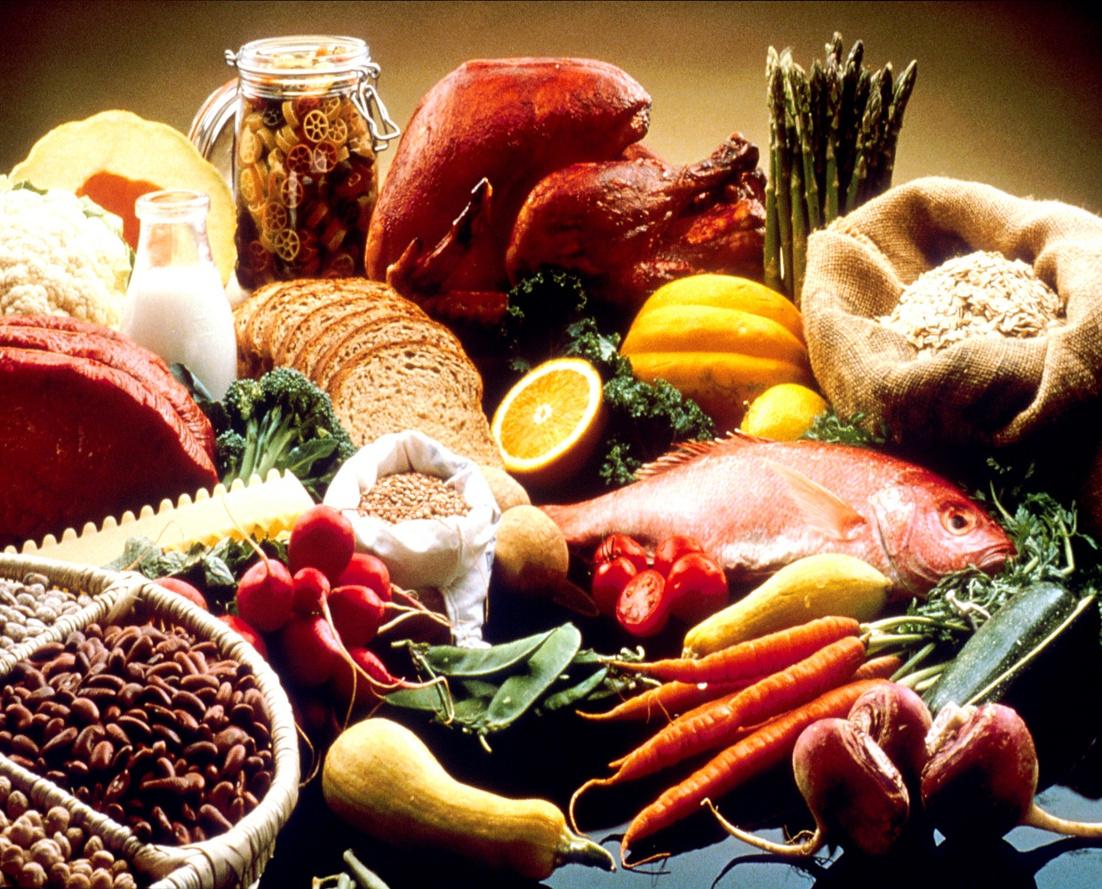

|  |  |  |
| --- | --- | --- |
| **Meat**  Ground beef  Chicken breast  Egg white  Turkey breast  Veal  **Seafood**  Bass  Clams  Cod  Crab  Halibut  Lobster  Scallops  Sea bass  Shrimp  Tuna (canned)  salmon | **Serving size**  1 oz.  1 oz.  1 large  1 oz.  1 oz.  1 oz.  1 oz.  1 oz.  1 oz.  1 oz.  1 oz.  1 oz.  1 oz.  1 oz.  1 oz.  1 oz. | **Protein**  7g(5 fat)  8g  3g  8g  10g  7g(1 fat)  7g (1 fat)  6g  6g  7g  6g  5g  7g  6g  7g  6g(3 fat) |

**Carbohydrate sources**

|  |  |  |
| --- | --- | --- |
| **Fruit**  Apple  Apricots, dried  Banana  Cantaloupe  Cherries with pits  Grapefruit  Grapes  Kiwi  Mango, peeled  Nectarine  Orange  Peach  Pear  Pineapple  Plum  Raisins  Strawberries  Watermelon | **Serving size**  ½ medium  1 oz  ½ medium  1 cup  1 cup  ½ medium  1 cup  1 medium  2 oz  1 medium  1 medium  1 medium  ½ medium  ½ cup  1 medium  2 tbsp.  ½ cup  1cup | **Carbs**  11g  10g  14g  14g  13g  11g  15g  12g  10g  16g  17g  10g  13g  10g  9g  16g  6g  12g |

|  |  |  |
| --- | --- | --- |
| Breads  Bagel  Pita Bread, white  Pumpernickel  Rye bread  Wheat bread | **Serving size**  1 large  1 slice  1 slice  1 slice  1 slice | **Carbs**  43g  29g  16g  16g  12g |

|  |  |
| --- | --- |
| **Cereals/Grains**  Cream of wheat  Grape-Nuts  Nutri-Grain  Oatmeal  Puffed wheat  Shredded Wheat  **Pasta/Potatoes/Rice**  Pasta  Potato, baked  Potato, boiled  Potato, sweet  Rice, brown  Rice, white  Rice cakes  Yam | **Carbs**  30g  24g  24g  27g  11g  19g  21g  26g  27g  25g  25g  25g  20g  9g  19g |

|  |  |  |
| --- | --- | --- |
| **Veggies**  Asparagus  Beans, green  Beets, sliced  Broccoli  Brussels sprouts  Cabbage  Carrots  Cauliflower  Celery  Corn  Cucumber  Eggplant  Lentils  Lettuce, iceberg  Lettuce, romaine  Mushrooms (cooked)  Mushrooms, raw  Onion  Peas  Peppers, green, red  Radishes  Sauerkraut  Spinach  Tomatoes  Squash, summer  Squash, winter | **Serving size**  1 cup/12 spears  ½ cup  ½ cup  1 cup  1 cup  1 cup  ½ cup or 1 whole raw  1 cup  1 cup/4 stalks  ¼ cup  2 cups  1 cup  ¼ cup  ½ head  3 cups  1 cup  1cup  ½ cup raw  ½ cup  1 pepper  4 medium  1 cup  1 cup  1 raw  1 cup  ½ cup | **Carbs**  9g  4g  9g  10g  13g  7g  8g  6g  4g  7g  6g  6g  10g  6g  4g  8g  3g  6g  6g  4g  1g  10g  7g  5g  8g  9g |

**Fats sources**

|  |  |  |
| --- | --- | --- |
| **Nuts**  Almonds  Almond butter  Cashews  Cashew butter  Macadamia nuts  Peanuts  Peanut butter  Walnuts  **Oils**  Almond  Canola  Corn  Olive  Peanut  Sesame  **Other**  Avocado  Guacamole  Olives | **Serving size**  ½ oz.  ½ oz.  ½ oz.  ½ oz.  ¼ oz.  ½ oz.  1 tbsp.  ½ oz.  1 tsp  1 tsp  1 tsp  1 tsp  1 tsp  1 tsp  1 oz. trimmed  1 tbsp.  1 oz. green, pitted | **Fat**  8  8  7  7  6  7  8  8  5  5  5  5  5  5  5  6  4 |