



The ultimate Athlete

What does it take to be the ultimate athlete? OR even just Athlete?

Is it speed, is it power, or is it all natural talent?

The answer is all (to a certain point)*insert laugh. People are always going to be better than others or specialize more so in certain fields. You have sprinters, jumpers, long distance runners, basketball players, football etc. But in the end, we all use the same types of exercises and training to our needs.

This program is for you to tap into your inner athlete and enhance it. We will hit all types of training and figure out what you need to do to become better. Let's talk about muscle fibers and how they play a role in your training.

*Type I

*Type IIA

*Type IIB

Starting with Type 1, these fibers are known as (slow twitch oxidative) and characterized by Power/Speed/low force along with high endurance (powerlifters, long distant sprinters). Contraction speed is low, about 100 milliseconds to obtain peak power output but fatigues slow.

Type IIA, these fibers are known as (fast twitch oxidative) and characterized by Force/Power/Speed producing high endurance (basketball, football, track athletes). Contractions speed fast, about 50 milliseconds to obtain peak power output but fatigues fast.

Type IIB, these fibers are known as (fast twitch glycolytic) and characterized by high Force/Power/Speed along with low endurance (Short burst sprinters). Contractions speed is very fast, about 25milliseconds to obtain peak power but fatigues fast.

Why do I need to know this?

Because depending on what we are training for, it is best to understand your needs first as an athlete, do you need more endurance? Do you need to become faster? Do I need to be stronger or jump higher? In my opinion you still need all of those but some more than others.

I love to preach “Train how you need to, and let the body take care of the rest” meaning with this training you will get into shape externally and internally just do what needs to be done. I will break this Routine down into 4 weeks that you will do for 3 months also separate from this will be additional programs for type I, IIA, IIB if you feel like you need more work in those areas. But right now, we are going to focus on all of them.

Week 1 and 2 will be all about getting use to how athletic movement can be enhanced in the weight room, we will be hitting it hard but also be adding in plyometric movements so we stay loose and teach our bodies how to react under fatigue. The weights are a tool we must use to better ourselves, I feel like a lot of us do not understand how much it teaches us about our own bodies and what we are capable of. Taken in what you have just learned about muscle fibers, try to point out your week points these couple of weeks.

Helps to know

Bench Max:

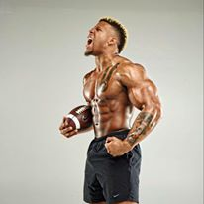Bodyweight bench max reps

Squat Max:

Strict overhead Max:

Deadlift Max:

Vertical jump:

Broad jump:

40 yrd:

1 mile:

Tips

*Understand your weight, if you can breeze through reps then you are not working hard enough, if it says 10 reps and you could have done 15-20 then you need to restart and up your weight. The last 3-4 reps should be a grind, don’t cheat yourself.

*Google is always there if you don’t understand something

* rest time will be given on first week, then I want you to try to adapt to the time given weather you can do it or not, heavy weights always more rest time, as to lower weights shorter.

Key

*Pyramid means a set that is done were weight increases a rep lowers each set or every other set, and sometimes decreases if the rep number goes higher.

* Supersets are A1 or A2 which means one is done right after the other has been completed

*AMRAP means “as many reps as possible”

*Everything is about max output and performance so if rest time given isn’t enough time, it is ok, don’t stress yourself over it you will get better

The Warm Up (Everyday)

Dead bugs: 10 each side

Glute bridge: 10

Single leg glute bridge: 8 (each leg)

Fire hydrate(Front)(Back): 10 each leg

Cross body push up reach: 10 each arm

Sumo squats: 20

Reaction ankle jumps: 3 sets 6sec

High knees: 10sec

Arm circles (forward)(back): 10sec both ways

Burpees: 3x5

Let’s get it...

The Stretch (After every workout)

30sec holds

Downward Dog

Cat

Cow

Side Oblique Stretch

Sumo Squat Twist

Child’s Pose

Figure 4

Half Kneeling Twist

Side Lunge Stretch

Pigeon

The Runner’s Stretch

The Seated Back Twist

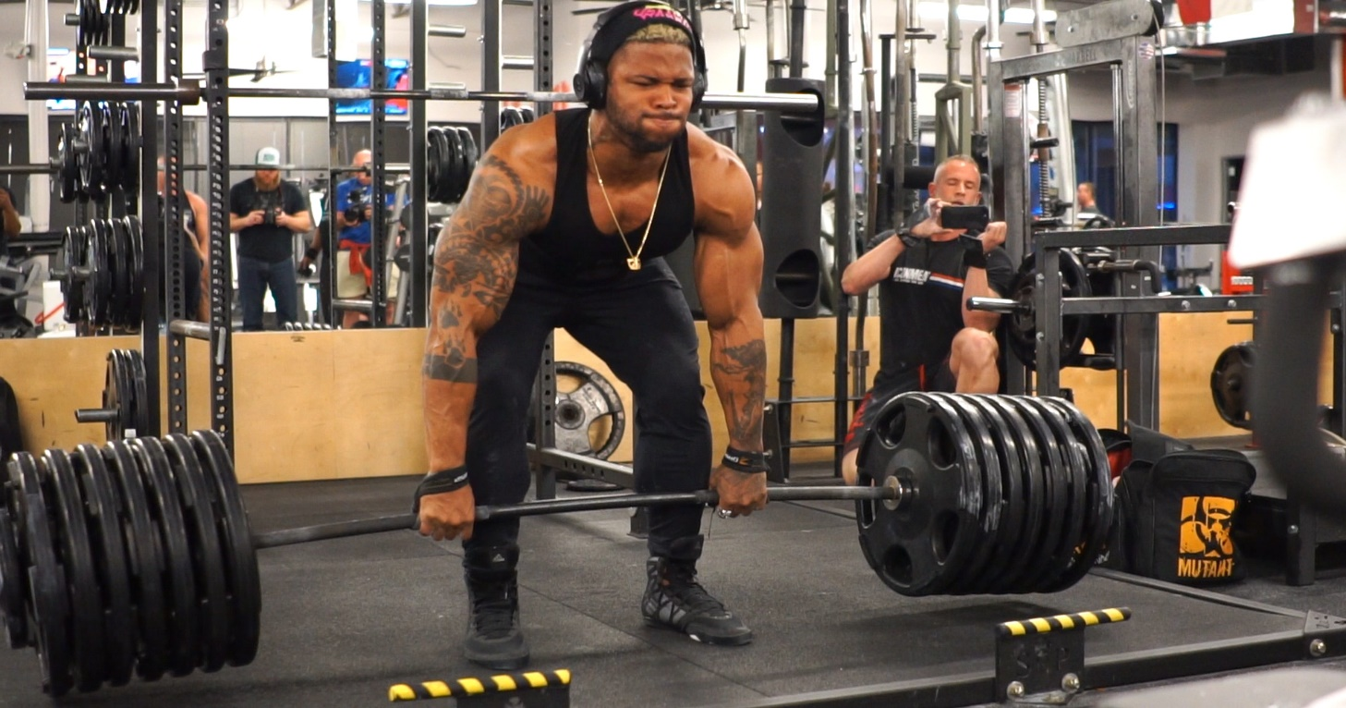

Week 1

Day 1

Upper body

Med ball wall chest press (kneeling): 3 sets AMRAP 20sec (40sec rest)

(light) Resistance band bench press (50% max): 5sets 8 (40sec rest)

Single arm dumbbell floor press: 4 sets 10 (30sec rest)

Pull up holds: 5 sets 2 reps hold at top for 10sec (1min rest)

(on all fours) Floor Dumbbells rows: 5sets 10 reps (40sec rest)

Overhead kettle bell carry: 3 sets 60sec (1min rest)

Rowing ergometer: 3 sets 500m (1min rest)

Day 2

Lower body

A1 Bulgarian split squat: 5 sets 10 each leg

A2 Bulgarian split squat (single leg jump "body weight") 5 sets 3 (45sec)

Single leg Hamstring curls: 5 sets 10 (45sec)

Side lunges(weights): 3 sets 10 (30sec)

Good mornings: 4 sets 15 (45sec)

Glute bridge: 5 sets 6 (80%) (60sec)

Single leg (leg press): 5 sets 10 (45sec)

Depth jumps: 4 sets 5 (45sec)

*stand on bench, step down, jump as high as you can on impact

Single leg (reaction ball): 4 sets 10 throws each leg (45sec)

*use a lacrosse or small bounce ball, find a wall, stand on one leg,

Throw and catch but Keep balance

Day 3

Conditioning

Interval 1 (1-1:30min rest)

Kettle bell swings: 5 sets 10

Squat jumps: 5 sets 20

Ab wheel: 5x 10

Interval 2 (back to back) 1-1:30min rest

Leg raises: 3 sets 15

Ab wheel rolls: 3 sets 15

Burpees: 3 sets 10

6 times (sprint 100m walk 100m)

Day 4

Upper body

Dumbbell Incline bench press: 2 sets 12 / 2 sets 8 / 1 set 6 (45sec rest)

Rack pulls: *pyramid set*. 12reps/8reps/6reps/8reps/12reps

(Start light work heavy then back down to light)

Pull ups: 3 set AMRAP(60sec)

Mid chest Cable cross overs: 3 sets 16

Standing shoulder press: 5 sets 8 (mid-heavy) (60sec-1:30)

Kettlebell overhead snatches: 3 sets 8(30sec)

Lateral/front raises: 5 sets 10(30sec)

Treadmill hand walks: 4 sets 1min hand walk on treadmill (45 sec rest)

Day 5

Lower body

Med ball slams: 5 sets 8(30sec)

A1 Leg extensions: 3 sets 20 reps

A2 squat jumps: 3 sets 10 (30sec)

Front squats: 5 sets 8 (60sec)

Step ups: 4 sets 6 reps (each leg) (45sec)

Seated calve raises: 5 sets 20(30sec)

Hip adductor/abductor: 4x15 (both ways) (45sec)

Monster crawls: 4 sets 10 count (30sec) "get in a crawling position on floor, raise knees off of ground, keep butt low and crawl. One arm and leg st s time equals one.

Single leg (reaction ball): 4 sets 10 throws each leg(20sec)

*use a lacrosse or small bounce ball, find a wall, stand on one leg, Throw and catch but Keep balance

Day 6

Arms & Abs (Rest time 30sec)

Triceps extensions: 20-8-8-20

V bar triceps push down: 20-8-8-20

Bicep curls: 20-8-8-20

Drag curls: 20-8-8-20

Triceps Overhead extensions: 8-20-20-8

Skull crushers: 8-20-20-8

Dumbbell curls: 8-20-20-8

Reverse curls: 8-20-20-8

Lying leg raises: 4 sets 16

Cable oblique twist: 4 sets 16

Weighted sit ups: 3 sets 10

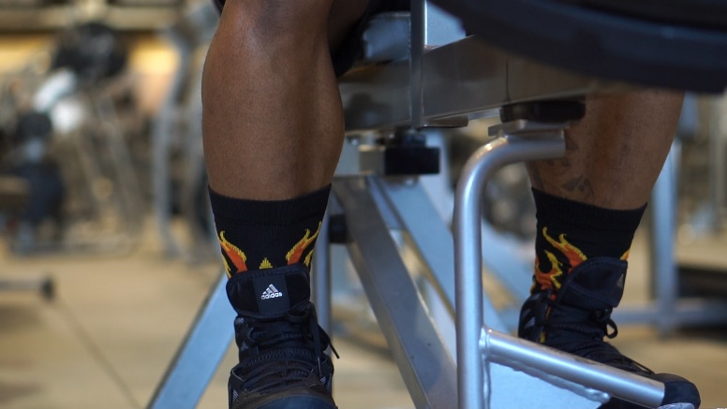Day 7 (off)

WEEK 2

Day 1

Upper body

Med ball backwards throw against wall: 3 sets AMRAP 30sec

bench press (80%-100%): 5-5-3-1

explosive pushups: 2 set AMRAP

Single arm dumbbell: 4 sets 10 (30sec rest)

Pull up: 3 sets AMRAP 30sec

Dumbbells rows: 5sets 10 reps (40sec rest)

Farmers Walk carry: 3 sets 60sec (1min rest)

Rowing ergometer: 3 sets 700m (1min rest)

Day 2

Lower body

Squat (70%): 4 sets 8

Jump Squats ("body weight") 5 sets 10

Standing calve raises: 5 sets 20

Single leg Hamstring curls (negatives): 5 sets 4

Glute bridge: 5 sets 6 (70% squat)

Single leg (leg press): 5 sets 10

Box jumps: 4 sets 10

Day 3

Conditioning

Interval 1 (1-1:30min rest)

Kettle bell swings: 5 sets 10

Squat jumps: 5 sets 20

Ab wheel: 5x 10

Interval 2 (back to back) 1-1:30min rest

Leg raises: 3 sets 15

Ab wheel rolls: 3 sets 15

Burpees: 3 sets 10

Single leg (reaction ball): 4 sets 10 throws each leg

*use a lacrosse or small bounce ball, find a wall, stand on one leg,

Throw and catch but Keep balance

Treadmill (backwards walking): incline 4 comfortable speed for 10min

Day 4

Upper body

Incline bench press: 4 sets 10 (45sec rest)

Deadlifts: *pyramid set*12reps (45%)/10reps (55%)/6reps (h70%)/6reps (70%)

Pull ups: 3 set AMRAP

Standing shoulder press: 5 sets 5 (heavy)

High pulls: 3 sets 8

Lateral/front raises: 4 sets 10

Treadmill hand walks: 4 sets 1min hand walk on treadmill (45 sec rest)

Day 5

Lower body

Box jumps: 5 sets 8

A1 Med ball hold jump squats: 3 sets 10 reps

A2 squat jumps: 3 sets 3

Front squats: 5 sets 8 (65%) 1-2min rest

A1 Seated calve raises: 4 sets 15

A2 Standing calve raises: 4 sets 15

Step ups: 4 sets 8 reps (each leg) 45sec rest

Hip adductor/abductor: 4x15 (both ways)

Monster crawl holds: 4 sets 30sec count

Day 6

Arms & Abs (optional)

Close grip bench: 20-8-8-20

V bar triceps push down: 20-8-8-20

Ez bar curls: 20-8-8-20

Reverse curls: 20-8-8-20

Triceps rope: 20-8-8-20

Triceps rope overhead: 20-8-8-20

Dumbbell hammer curls: 20-8-8-20

Lying leg raises: 4 sets 16

Cable oblique twist: 4 sets 16

Weighted sit ups: 3 sets 10

Day 7 (off)

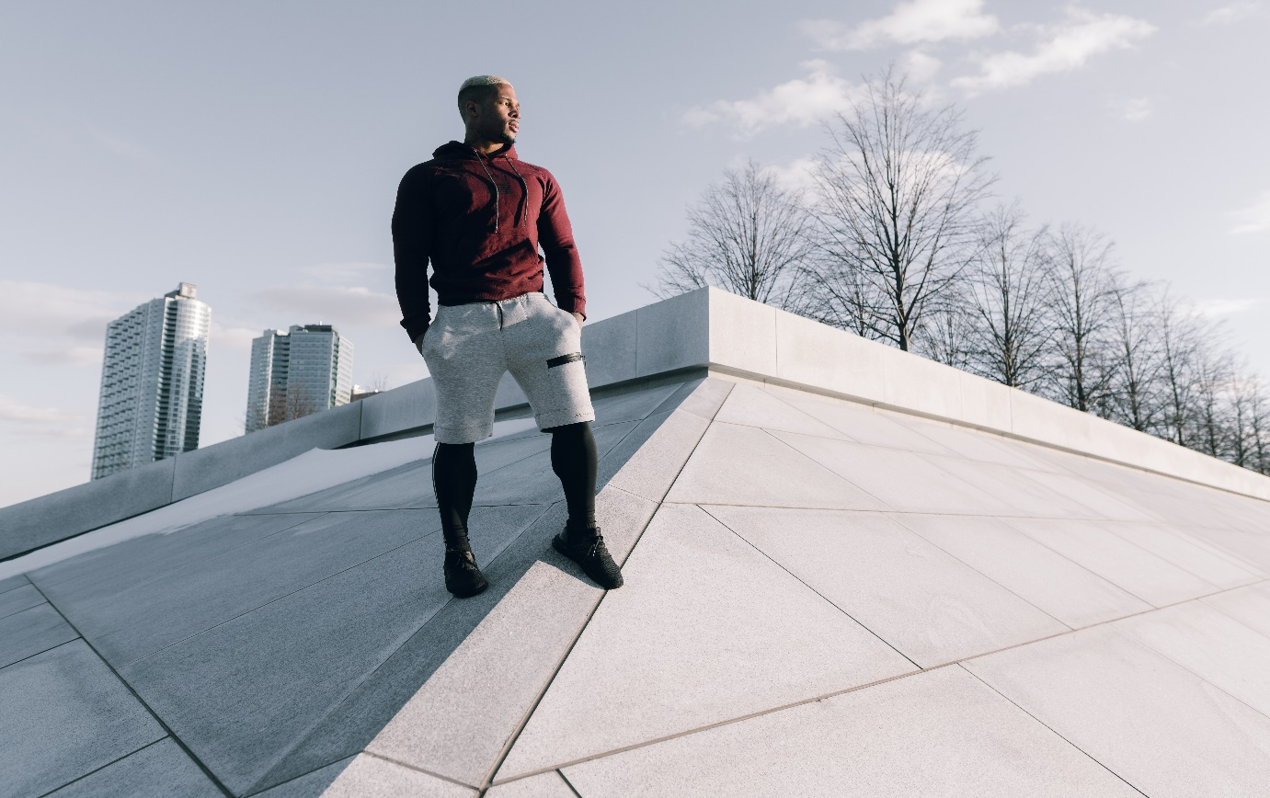

Week 3

Day 1

Med ball wall backwards throw against wall: 3 sets AMRAP 30sec

A1 bench press (75%-85%): 5-5-5

A2 explosive pushups: 4

Standing Strict Press: 6 sets 3 (1:00rest)

Single arm dumbbell snatch: 4 sets 10 (30sec rest)

Muscle snatch: 5sets 10 reps (40sec rest)

(hang clean without the clean, like a high pull)

Overhead Farmers Walk carry: 3 sets 60sec (1min rest)

Pull Ups: 3 sets AMRAP

Push press: 3 sets AMRAP

HIIT 1 Interval

60 sec jump rope

40 sec lateral jumps

20 sec burpees

3 times with (1min rest)

Day 2

Lower body

A1 Squat (85-90%): 5 sets 3

A2 Jump Squats ("body weight") 3

Snatch grip deadlift: 4 sets 10

Single leg glute bridges(barbell weighted) "60% squat max": 4 sets 8

Explosive Complex interval

Hang clean: 30 se

Burpees: 30sec

Box jump (below knee): 30 sec

3 sets (1 min rest)

Day 3

Conditioning

Sprints: 10 sets 20yrd or bike sprints: 10 sets 30 seconds

Interval 1 (1-1:30min rest)

Push up position(hold): 5 sets 60sec

Knee tuck jumps: 5 sets 30sec

Ab wheel: 5 sets 1min

Interval 2 (back to back) 1-1:30min rest

Leg raises: 3 sets 60sec

Burpees: 3 sets 60sec

Dead bugs: 3 sets 60sec

Treadmill (backwards walking): incline 4 comfortable speed for 10min 120bpm heart rate

Day 4

Upper body

Incline dumbbell bench press: 5 sets 8(45sec rest)

Pull ups: 3 set AMRAP

Seated shoulder press: 5 sets 10

Zercher holds(hold bar at elbow crease): 3 sets 30sec (heavy)

Lateral/front raises: 5 sets 10

A1 Seated weight runners to weightless: 3 sets 10sec

(hold 5lb plates in each palm in a runner stance seated, act as if you are sprinting with the weights in your hands)

Weight to weightless broad jumps: 4 sets 4 jumps

Treadmill hand walks: 4 sets 1min hand walk on treadmill (45 sec rest)

Day 5

Lower body

Box jumps: 5 sets 8

A1 Med ball hold jump squats: 3 sets 20 reps

A2 squat jumps: 3 sets 3

Hip adductor/abductor: 4x15 (both ways)

Front squats: 5 sets 5 (85%) 1min rest

Step ups: 4 sets 6 reps (each leg) 45sec rest

Beast crawls: 4 sets 10 count

Day 6

Arms & abs

V bar triceps push down: 20-8-8-20

Bicep curls: 20-8-8-20

Triceps Overhead extensions: 8-20-20-8

Skull crushers: 8-20-20-8

Dumbbell curls: 8-20-20-8

Triceps rope: 8-20-20-8

Lying leg raises: 4 sets 16

Cable oblique twist: 4 sets 16

Weighted sit ups: 3 sets 10

Day 7 (off)

Week 4 (Testing)

It’s time to put up or shut up.

Day 1

Vertical jump:

Broad jump:

40 yrd:

1 mile:

Day 2

Bench Max:

Deadlift Max:

Day 3

Light Cardio:

20min Treadmill BPM 120

Stretching session.

Day 4

Squat Max:

Standing military press:

Day 5

Bodyweight bench test:

Day 6 (How tough are you) *optional.. sike

Lying burpees: AMRAP 1min

Pushups: AMRAP 1min

Pull ups: AMRAP 1min

Step ups: AMRAP 1min

Squat jumps: AMRAP 1min

3 rounds

Keep count of how many each round.

Day 7 (OFF)

So. How did we do?? I’m 100% positive you made great progress, but in some cases sometimes things may go off task, ask yourself how was my energy, my work schedule, stress, or most importantly my food intake. Life is tough sometimes and we tend to get side tracked but that’s ok we can still become better.

Well you have this for 3 more months starting back to week one. Now be great!!!

I truly hope this was worth it for you please feel free to share also follow my pages.

YouTube channel: [www.youtube.com/terron2311](http://www.youtube.com/terron2311)

Instagram: [www.instagram.com/terron2311](http://www.instagram.com/terron2311)

Twitter: [www.twitter.com/fbaftermath](http://www.twitter.com/fbaftermath)

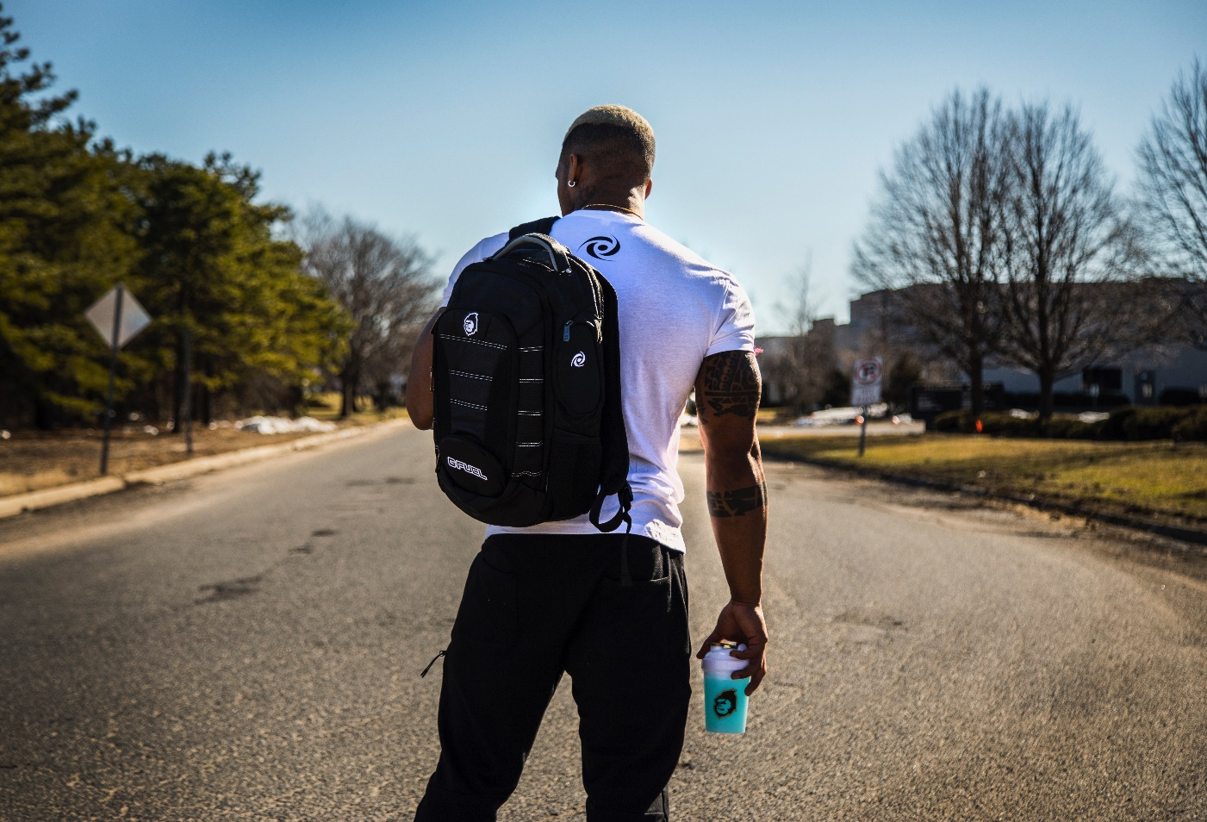

Supplements

PRE-Strength Formula: Gammalabs 24K ‘Aftermath” for discount [WWW.gammalabs.net](http://WWW.gammalabs.net)

Agmatine sulfate (nitric oxide) Any company (Raw ingredient)

Cla (body composition) (burn fat)

Forsklin (burn fat)

Food

Now as we all know depending upon your goals, our food intake differs. With this program, I would like for you to have macros of

1g protein lean body mass

1.5g carb body weight

if overweight 1.5g carb lean body mass

.25g fat lean bodyweight

This is a good start but as I said we all are different, so this is a basic layout for everyone to lean on and then you can make changes from there. As an athlete, we need the carbs to help us through our workouts, no need to gouge on high amounts of protein, it hinders your as we say “GAINZ”. As you should know protein takes time to break down, if we do not let the body do its job in a good timely manner well, the weight adds on. Here is a list of foods to go off with all of the information needed to count properly.

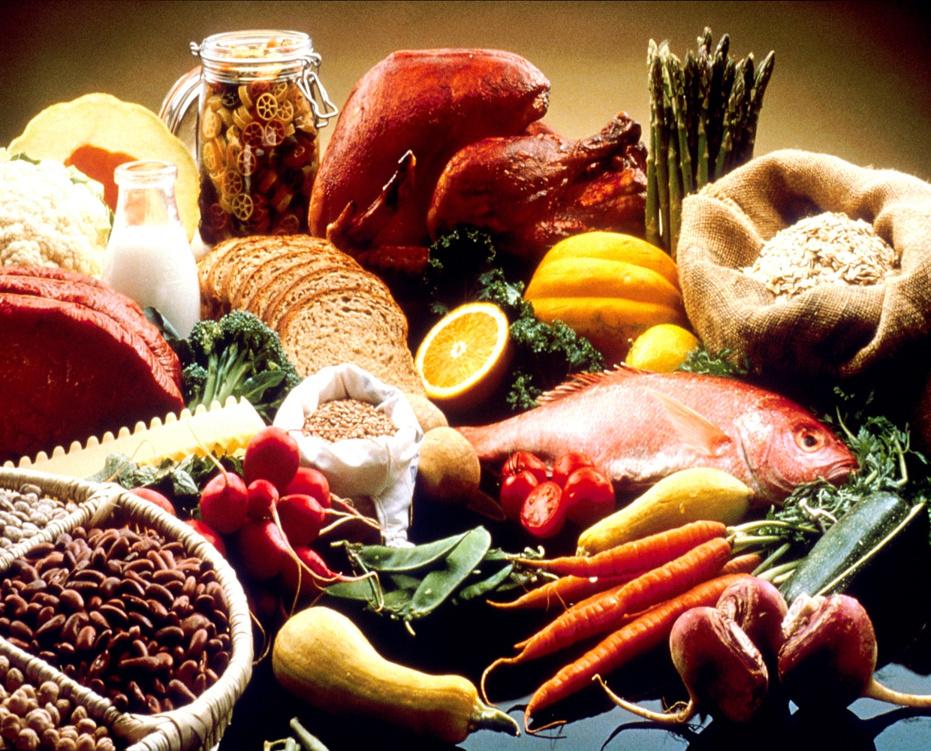

|  |  |  |
| --- | --- | --- |
| **Meat**  Ground beef  Chicken breast  Egg white  Turkey breast  Veal  **Seafood**  Bass  Clams  Cod  Crab  Halibut  Lobster  Scallops  Sea bass  Shrimp  Tuna (canned)  salmon | **Serving size**  1 oz.  1 oz.  1 large  1 oz.  1 oz.  1 oz.  1 oz.  1 oz.  1 oz.  1 oz.  1 oz.  1 oz.  1 oz.  1 oz.  1 oz.  1 oz. | **Protein**  7g(5 fat)  8g  3g  8g  10g  7g(1 fat)  7g (1 fat)  6g  6g  7g  6g  5g  7g  6g  7g  6g(3 fat) |

**Carbohydrate sources**

|  |  |  |
| --- | --- | --- |
| **Fruit**  Apple  Apricots, dried  Banana  Cantaloupe  Cherries with pits  Grapefruit  Grapes  Kiwi  Mango, peeled  Nectarine  Orange  Peach  Pear  Pineapple  Plum  Raisins  Strawberries  Watermelon | **Serving size**  ½ medium  1 oz  ½ medium  1 cup  1 cup  ½ medium  1 cup  1 medium  2 oz  1 medium  1 medium  1 medium  ½ medium  ½ cup  1 medium  2 tbsp.  ½ cup  1cup | **Carbs**  11g  10g  14g  14g  13g  11g  15g  12g  10g  16g  17g  10g  13g  10g  9g  16g  6g  12g |

|  |  |  |
| --- | --- | --- |
| Breads  Bagel  Pita Bread, white  Pumpernickel  Rye bread  Wheat bread | **Serving size**  1 large  1 slice  1 slice  1 slice  1 slice | **Carbs**  43g  29g  16g  16g  12g |

|  |  |
| --- | --- |
| **Cereals/Grains**  Cream of wheat  Grape-Nuts  Nutri-Grain  Oatmeal  Puffed wheat  Shredded Wheat  **Pasta/Potatoes/Rice**  Pasta  Potato, baked  Potato, boiled  Potato, sweet  Rice, brown  Rice, white  Rice cakes  Yam | **Carbs**  30g  24g  24g  27g  11g  19g  21g  26g  27g  25g  25g  25g  20g  9g  19g |

|  |  |  |
| --- | --- | --- |
| **Veggies**  Asparagus  Beans, green  Beets, sliced  Broccoli  Brussels sprouts  Cabbage  Carrots  Cauliflower  Celery  Corn  Cucumber  Eggplant  Lentils  Lettuce, iceberg  Lettuce, romaine  Mushrooms (cooked)  Mushrooms, raw  Onion  Peas  Peppers, green, red  Radishes  Sauerkraut  Spinach  Tomatoes  Squash, summer  Squash, winter | **Serving size**  1 cup/12 spears  ½ cup  ½ cup  1 cup  1 cup  1 cup  ½ cup or 1 whole raw  1 cup  1 cup/4 stalks  ¼ cup  2 cups  1 cup  ¼ cup  ½ head  3 cups  1 cup  1cup  ½ cup raw  ½ cup  1 pepper  4 medium  1 cup  1 cup  1 raw  1 cup  ½ cup | **Carbs**  9g  4g  9g  10g  13g  7g  8g  6g  4g  7g  6g  6g  10g  6g  4g  8g  3g  6g  6g  4g  1g  10g  7g  5g  8g  9g |

**Fats sources**

|  |  |  |
| --- | --- | --- |
| **Nuts**  Almonds  Almond butter  Cashews  Cashew butter  Macadamia nuts  Peanuts  Peanut butter  Walnuts  **Oils**  Almond  Canola  Corn  Olive  Peanut  Sesame  **Other**  Avocado  Guacamole  Olives | **Serving size**  ½ oz.  ½ oz.  ½ oz.  ½ oz.  ¼ oz.  ½ oz.  1 tbsp.  ½ oz.  1 tsp  1 tsp  1 tsp  1 tsp  1 tsp  1 tsp  1 oz. trimmed  1 tbsp.  1 oz. green, pitted | **Fat**  8  8  7  7  6  7  8  8  5  5  5  5  5  5  5  6  4 |